TRINITY PRIMARY SCHOOL-BUKOTO
NATURE OF WORK: REVISION WORK
SET: 5
SUBJECT: MATHEMATICS
CLASS: P.4
NAME: ______________________________ DATE ___________
SECTION A:
1. | Add: 12+ 12 = | 7. | Change 4 weeks to days.
2. | Find the value of 5 tens. | 8. | Write 781 in words.
3. | Name the set symbol below. | 9. | Work out: +3 = 9
4. | What is the sum of 21 and 20? | 10. | Arrange the following numbers from smallest to biggest.  10, 5, 7, 12, 3, 2
5. | Draw a cone in the space provided below. | 11. | represents 12 balls.How many balls are represented by?
6. | Subtract: ⁵/₁₀ – ²/₁₀ = | 12. | Find the place value of 2 in the number  4264.

13. | Show 7o’clock on the clock face below.  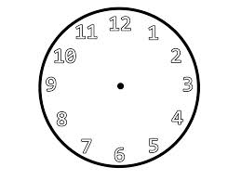 |  | 17. |  | Describe the shaded region.  Y  X
14. | Use a number line to work out 10 -7.  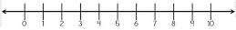 |  | 18. |  | One book costs 500/=.what is the cost of 4 similar books?
15. | Complete using a correct operation  +, _, ÷, or x.  12 6 = 2 |  | 19. |  | Find the perimeter of the figure below.  3 cm  6cm
16. | Using repeated addition, complete  4 + 4+ 4 = 4 x_____ |  | 20. |  | Musa had sh.1000 and bought  a book at sh.600.How much did he remain with?
21. | SECTION B:  (a) Tell the time shown on the clock face.  (i) _______________  (ii) ________________  (b) Show 20 minutes past 3 o’clock. |  | 23. |  | Below is Loreta’s shopping list. Use it to answer questions that follow.  -Sugar for sh.3,000 each kg  -Bread for sh.4,000 each loaf  -Rice for sh.2,000 each kg.  - How much did she use to buy 2 kgs of sugar?  (b) Name the cheapest item.  (c) Find the total cost of the three items.
22. | (a) Work out the area of the rectangle below.  2cm  6 cm  (b) Find the perimeter of the rectangle above.
22. |  |  | 24. |  | (a) Draw a cuboid in the space below.
24. | - Name the shapes below.  __________________________  (ii)  _______________  (iii)  _________________  (iv) 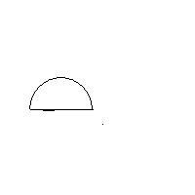 _______________________ |  | - Find the number of elements found in set K.  - How many elements are there in set KUM?  - List down all members which form set K∩M.
24. |  |  | 26.  Tom Alex Ali  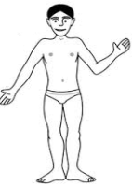__10m_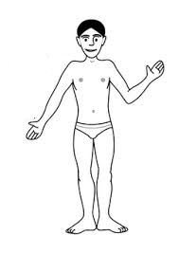____5 m__  (a) Which two boys are 5m apart?
25. | Study the Venn diagram below and use it to answer questions that follow.  K M  a f g b h  a  e d c  a
 | (b) What is the distance between Tom and Ali?  - Find the distance between Tom and Alex. |  |  | (b) On which day did the above Month start?  (c) How many Sundays are in the above Month?  - How many days are in the above Month?
27. | Use the calendar below to answer questions that follows.  - How many full weeks are in the month above?
  S | M | T | W | T | F | S
   |  |  |  |  |  | 1
  2 | 3 | 4 | 5 | 6 | 7 | 8
  9 | 10 | 11 | 12 | 13 | 14 | 15
  16 | 17 | 18 | 19 | 20 | 21 | 22
  23 | 24 | 25 | 26 | 27 | 28 | 29
  30
27. |  |  |  | 28. Study the magic square below  (a)Find the magic sum.
  9 | a | 7
  c | 6 | 8
  5 | b | 3
 | - Find a.  - Find b.  - Find c. |  |  | (b) How old is Alfred than Martin?  (c) Who is younger?  (d) What is their total age?
29. | Work out:  - + 5 = 15  - - 3 = 10
29. | Work out:  - + 5 = 15  - - 3 = 10 | 31. |  | Mukisa ate ¹/₅ of a mango and Mwebaza ate ²/₅ of a mango.  - Who ate the biggest part?  - What fraction did they eat altogether?
30. | Alfred is 26 years old. Martin is 19 years old.  - How old is Alfred?

- Shade the fraction Mukisa ate.

= ¹/₅

32. | Complete the table below correctly by showing the working.
  WEEKS | 1 | _____ | 2 | _____ | 5
  DAYS | 7 | 28 | ______ | 21 | ______

